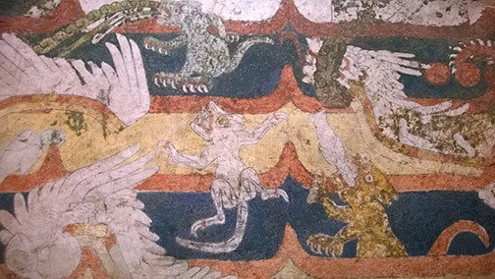
Detail from The Mural of the Mythological Animals, 250 - 350 CE, Teotihuacan, Street of the Dead. This and many artworks from Teotihuacan are on view at the De Young Museum, San Francisco, in the exhibition, Teotihuacan, City of Water, City of Fire, through February 11.

Latin American and Latina/o Art 111
TTh 3-4:15 pm
Kadema 145
Professor Elaine O'Brien Office: Kadema 190 Hours: W 2:30-5 pm eobrien@csus.edu
http://www.csus.edu/indiv/o/obriene/

Course Description: This Writing Intensive course is an overview of several thousand years of art history of Latin American (the Rio Grande south to Cape Horn) and Latina/o art to the present. After an introduction to major ancient cultures with selected readings and documentary films about Mesoamerican and Andean cultures, our focus shifts to Spanish and Portuguese colonial art. We look at the art of the Independence Era in the first half of the 19th century, the rise of modernism across Latin America in the 1920s, and finish our course with selections of contemporary Latin American and Latina/o art, with a focus on regional Chicana/o art. We will look briefly at the art of the Latin American African Diaspora, focusing on the former French Caribbean colony of Haiti. A trip to see Diego Rivera’s Pan American Unity mural at the Ocean Campus of San Francisco City College is assigned. The expansive geographical and historical breadth of the course allows us to ask what (if any) identifiable forms, attitudes, and concepts characterize “Latin American and Latina/o” art.

Note: You are required to attend the Festival of the Arts Art History Symposium,
Mapping Art History, with lectures by scholars of ancient Mexican art, on Saturday, April

Please clear and mark your calendars now and see me if you have a conflict that can’t be resolved.

Prerequisites: Completion of GE Areas A2, A3, second-semester composition (ENGL 20), junior standing, and ENGL 109M/ ENGL 109W. Students who take the WPJ instead of initially taking ENGL 109M/ ENGL 109W must score 70, 71, or 80. Students with a lower WPJ score will have to complete other prerequisites determined by their score.

Catalog Description: Provides an overview of Latin American and Latino art from the independence movements of the 1820s to the present. After an introductory survey of pre- Columbian and Spanish colonial art, the art of Mexico, Central and South America, the Caribbean and the U.S. is studied within the contexts of contemporaneous cultural, intellectual, political, and social history. The diverse visual cultures of Latin American and Latino art are thematically unified by an examination of common concerns and motivations.

University expectations for Writing Intensive courses:
  - The course must build on the basic skills and knowledge acquired by students in their foundation courses in General Education or the major.
  - The course must expand students' knowledge by examining complex issues.
  - The course must expand students' abilities to reason logically and to write clearly in prose.
  - Students must be required to write not less than 5,000 words of clear and logical prose (not to include simple narrative or diary writing).
  - Instructors must work actively with students to sharpen analytical abilities and to improve their writing styles.
  - Writing assignments must be spread over the entire semester (with at least 3,000 of the 5,000 words due before the last two weeks of instruction).
  - Instructors must provide timely responses and evaluation of each writing assignment, and evaluations and comments must not only be about the subject matter content but also about writing skills.

Note: Art 111 is also a General Education course in Area C-1 (the Arts) and satisfies Area C-1 Learning Outcomes:
Students completing the C-1 requirement should be able to:
- Think conceptually and critically about medium, performance or presentation, and production for at least one art form;
- Demonstrate knowledge of artistic production, aesthetic properties, and the way creative work is shaped by artistic and cultural forces;
- Have an acquaintance with a broad understanding of artistic forms, genres, and cultural sources;
- Be able to develop and defend informed judgments about creative work;
- Demonstrate knowledge of the conventions of at least one of the disciplines in the arts.

Course Objectives:
- Increased knowledge and appreciation of forms, contents, and contexts of Latin American and Latina/o art and visual culture
- Advancement of skills in research, writing, and the articulation of visual concepts
- Advancement of information technology skills
- Development of analytic and critical thinking abilities
- Improved listening and public speaking skills
- Direct experience with a major artwork: Diego Rivera’s Pan American Unity mural at San Francisco City College Ocean Campus
- A grasp of the relationship between the form and content of artworks, the language of art, and insight into why works of art look the way they do
- Appreciation of the various social roles of the artist

To help you achieve these objectives and excel in this and other courses:
  - Dartmouth College Academic Skills website: https://students.dartmouth.edu/academic- skills/learning-resources/learning-strategies
  - Another good academic skills website: http://www.studygs.net/

Required texts: Always bring relevant textbook and articles in hard copy to class for discussion.
- Dawn Ades, ed., Art in Latin America: The Modern Era 1820-1980 (on syllabus as “Ades”) The chapters in Ades are available as scanned PDFs on the Art 111 “Readings” webpage.
- Mary Ellen Miller, The Art of Mesoamerica: From Olmec to Aztec, 5th edition (on syllabus as

“Miller”)
- Rebecca R. Stone, Art of the Andes: From Chavín to Inca, 3rd Edition
- Articles available for downloading from the Art 111 “Readings” webpage. Print the articles out and mark important information and ideas as you read. Bring your marked article to class for reference during discussion.

Course Requirements and Grade Basis:

10% participation: Good participation is how much you help others learn: a positive, questioning, engaged attitude toward the material in the class. This is evident in attendance, being on time, attentiveness, and note taking.

Please come to my office hours early in the semester and introduce yourself to me. Tell me about your personal learning goals, interests, and/or concerns. This is much more important than many students realize.
  - Note taking: Some of this class is discussion, but information presented in lectures contains information that will be on quizzes. According to cognitive research, listeners only recall 50% of what they hear and that 20-30% is incorrect. Therefore, taking good notes is crucial for learning success in college. Please review these suggestion on note taking: http://www.dartmouth.edu/~acskills/docs/taking_notes.doc
  - Participation during small-group discussion: at times during the semester you will be asked to participate in small-group and class discussion. It is during these discussions

that your participation (how much you help others learn) is most evident. Good and bad participation is noted on the roster and affects your grade.
    - Do not leave your group during small-group discussion to talk with me individually.
    - Do not leave the classroom during small-group discussions.
- Attendance is taken almost every time.
  - Three unexcused absences reduce your grade by one letter grade; each subsequent absence reduces your grade by a whole letter. Five unexcused absences result in automatic failure. Chronic lateness or leaving early (more than three times) can reduce your grade by one letter.
    - Excused with evidence: Illness and family/childcare emergencies are excused with a written note from your health-care practitioner or the student health clinic.
    - Not excused: Scheduled appointments, transportation problems, and job demands are not excused.
    - Note: I often excuse students who explain the reason for their absence to me in person during my office hours or by appointment.
    - Please do not hesitate to come to see me about family emergencies or any situation that will keep you from class. We can probably work something out that’s fair to you and the other students.
    - An email cannot excuse an absence. But always feel free to email me.
- Cell phones and all electronic devices must be turned off and out of sight during class. I will ask you to leave the class and count you as absent.
- No small screens are permitted, but large-screen laptops for note taking only are permitted on aisle seats only where I can see your screen when I walk around the room. If you are in a seat where I can’t see the screen, I will ask you to move or close your laptop and put it away. If you are using your laptop for purposes other than note taking, I will ask you to leave the class and count you as absent.
- No sleeping in class. Sleepers lower overall class energy and morale. If you are sleeping, I might ask you to leave class and count you as absent.
- No eating or drinking, please. I will ask you to put it away.

If you have a disability and require accommodations, you need to provide disability documentation to SSWD, Lassen Hall 1008, (916) 278-6955. Please discuss your accommodation needs with me after class or during my office hours early in the semester.

20% 1-page (250-300 words) reading response papers
For each of the “RReadings” indicated on the syllabus:
    - On top, write your name, date, author’s name, full title of the reading (put quotation marks around the title), and date of publication. In one sentence, give the author’s expertise in the subject. (Does he or she have a Ph.D. in the subject, or is he or she the author of books on the subject? Google for the information.)
    - Find and quote the author’s thesis statement in the article. Put the page number in parentheses next to the quoted thesis statement.

    - Put the author’s thesis statement in your own words. Your paraphrase should be about equal in length to the quotation.
    - Quote and paraphrase 3 key points the author makes - from the beginning, middle, and end of the reading. A “key point” is not merely interesting; it supports (proves) the credibility of the author’s thesis. A key point is usually a historical fact that the author is using as evidence that his or her claims are true.
    - Conclude with a short paragraph about what you learned about Latin American art from the reading.
    - There is a sample response paper on the course webpage for a workable format, but proving that you comprehend the reading well is the most important objective for you. If you have trouble understanding the essay, come see me during my office hours or by appointment. We can also make a telephone appointment.
NOTE: Late reading response papers are not accepted except for excused absences. The response papers are the basis of small group and class discussions and must be on time so you can contribute to the discussion.

10% Diego Rivera Mural at San Francisco City College: Response paper due April 10 NOTE: This assignment is worth 10 % of your grade and is also a make-up assignment for the missed class February 20 and 22. You are marked absent that week until the mural visit assignment is graded.
Before mid-April, visit the Diego Rivera mural, Pan American Unity (1940) at the Ocean Campus of San Francisco City College. http://www.riveramural.org/
      - Read the website and call the information number there before you go to get essential information about the history of the mural, open hours, maps, directions, parking.

Pan American Unity Mural Response paper:
- At least two full-length photographs of you with the mural. NOTE: The photographs are gatekeeper requirements. You get no credit at all without the photographs of you. Do not take selfies because they are too close. If you go alone, ask another visitor or the docent to take the pictures for you.
- A 20-minute detailed sketch of your favorite scene in the mural
- A 300-word response: a) briefly explain Rivera’s thesis and describe the story he tells in the mural; b) explain how the scene you selected helps establish Rivera’s thesis; c) conclude with a paragraph about what impressed you most about the mural and why.

      - Email the assignment to me as attachments, pictures (as JPEGs) and the written document (in Word or PDF). You may include the pictures in your written document if you prefer.
o Please do not use a shared drive.

20% 15-minute quizzes:

Quiz dates are indicated on the schedule, and changes are announced in class. After lectures are presented in class, I will make them available on the course website under “Lectures.” You can use the slides to make flash cards for the quizzes. I will only ask you to identify works of art and architecture that are both in the readings and shown in the videos and class lectures.

Quiz format: You will be asked to identify a work of architecture or art (or two works in a comparison). Identification includes 1) name and nationality of artist, 2) the title of work, 3) date of work. You will also be asked to respond to a question related to the lectures, discussions, videos, textbooks and readings.

30% Research Paper: An 8-page (1600-word, 12 font, double-spaced) research paper.

The Research Paper has the following parts:
      - Paper Proposal and Research Bibliography Grade: 50 points
      - First draft: 100 points
      - Second (final) draft: 100 points
      - Peer-review of your colleague’s paper: 50 points
      - Total 200 points

Start by selecting an artist as the topic for your paper from the list at the end of the syllabus. You may choose an artist not on the list, but you must get my approval before proceeding with your research and writing your proposal. Each student must write on a different artist. To make this possible, start by selecting three artists whose work interests you. Use the internet to read about the artists and make informed selections. Mark your favorite if you have one and submit your list to me in class. I will select one artist from your list for your research paper.

The thesis question for every research paper is the same: In what way(s) is the art made by the artist you selected “Latin American” or “Latinx”?
In your research, seek and find the answer to that question. Does the artist identify with a Latin American or national culture, like Mexico or Brazil? Have they said as much in an interview or writing? Do art writers identify their work as Latin American or Latinx? Can you see evidence in the art itself that the artist is drawing upon a Latin American heritage?

After you have done your preliminary research and reading, propose an answer to the thesis question and write it up as your thesis statement for the proposal. The research you do for the paper is to find out if your proposed thesis about the artist’s view of himself or herself as “Latin American or Latina/o” is correct. If you find out that your proposed thesis is not correct, change your thesis.

NOTE: If you want to do a research paper on a subject other than an artist’s identity, you may propose a topic to me. See me to discuss your idea during my office hours or email it to me for approval and direction. I may ask you to make an appointment with me to discuss your idea.

We will have a library class on information literacy, and I am available during my office hours to instruct you. You can also get instruction at the Writing Center in Calaveras Hall, and University librarians are available to help you at the reference desk on the second floor.

- Format: Chicago style full endnote and bibliographical citation style only. Do not use parenthetical citations
- Use Endnote and set it for Chicago Style. Endnote is available free for enrolled students: http://csus.libguides.com/c.php?g=768192&p=5510488
- Online quick guide to Chicago style citations: http://www.chicagomanualofstyle.org/tools_citationguide.html

For free, one-on-one help with writing in any class, visit the University Reading and Writing Center in Calaveras 128. The Reading and Writing Center can help you at any stage in your reading and writing processes: coming up with a topic, developing and organizing a draft, understanding difficult texts, or developing strategies to become a better editor. To make an appointment or a series of appointments, visit the Reading and Writing Center in CLV 128. We also offer tutoring for one unit of academic credit through ENGL121. For current Reading and Writing Center hours and more information, visit the website at www.csus.edu/writingcenter.

Late papers: Except for excused absences (see above), all parts of the research paper are marked down half a letter grade for each class they are late.

Paper Proposal and Research Bibliography Grade: 50 points / Due February 27
Evaluated on 1) the strength of the thesis statement, 2) the quality of the sources and length of the bibliography, and 3) the accuracy of bibliographical citation format.

  - Proposal: A one-page (250-word) thesis statement. Your thesis statement is the answer you propose to the class thesis question. For definitions of a thesis statement and how to write one, see website tutorial: https://wts.indiana.edu/writing-guides/how-to-write-a- thesis-statement.html
    - I recommend that you see me during my office hours in the first two weeks of class for help formulating a thesis. You can also email me your thesis statement (up to one week before the due date) if you want my help.
  - Research bibliography: This is a complete list of every source of information available on your topic.
    - The complete research bibliography is the starting point of your research and tells you what has been written on your topic. It should be at least four pages and include all credible sources on your subject in books, articles, films, documentaries, and on the web.
      - Primary sources (interviews and archival information) must be cited as well as secondary sources.
NOTE: You will probably not use most of the sources you put in your research bibliography. The research bibliography is a “complete” (everything published) not a “selected” (what was useful for your research) bibliography.
Note: your finished paper will include a bibliography that lists only the sources you actually used, which is called a “Sources Cited” bibliography.
    - Refer to CSUS library art history research resources: http://csus.libguides.com/arthistory

  - Use full-text peer-reviewed articles only. (definition: http://guides.lib.jjay.cuny.edu/c.php?g=288333&p=1922599
    - Using the University Library’s OneSearch, you can select for peer-reviewed articles. On the “Database and Article” search page off the University Library website, select “Art” and search using the selected databases.

Research Paper Drafts
- First and Second (final) draft have the same requirements:
- First draft is due March 27. Follow the same directions as below for the third (final) draft. I will correct the first draft and return it to you in time for you to revise your paper for peer review.
- Second Draft (for peer review): due April 12 / Your peer review (second) draft is exchanged with a student colleague. Mark your partner’s paper and address all questions on the “Peer review checklist for research papers,” which is available from a link on my website homepage in the left-hand column. Your peer review of your partner’s second draft is due April 24.

Third (final) draft and Portfolio due May 3
- An 8-page (1600-word, 12 font, double spaced) research paper, including footnotes, “Sources Cited” bibliography, and a Chicago-style cover page with your name, title of paper, course name, and date
- Reproductions of all artworks referred to in your paper with figure captions.
- Staple in upper left corner (*Please do not use plastic sleeves.)
- Submit the final draft with all the rest of your research paper assignments in a sturdy, new, flat, 2-pocket file. Include the drafts, including your peer reviewed draft, and all the work you’ve done: the original (marked) proposal, the research bibliography, and first draft. Submit all parts together. Your grade will be based on overall quality, effort, and presentation from start to finish.

Grading rubric for first and final drafts: 100 points for each draft
- Strength and clarity of thesis: 10 points
- Logic of argument development (composition): 25 points
- Strength of visual evidence: 15 points
- How clearly and concisely the conclusion sums up the argument and evaluates the thesis: 5 points
- Quality of scholarly sources: 10 points
- Accuracy of citation usage and format (footnote and bibliography): 10 points
- Quality of writing (grammar, syntax, punctuation, spelling, etc.) and overall presentation
= 25 points
o 100 total points: 100-90=A, 89-80=B, 79-70=C, 69-60=D.

Peer Review grade: 50 points
Your review of a peer’s “Peer-Review Draft” must be included in your peer’s term paper portfolio. Be sure your name is on it so I can give you a grade. (You may also make a copy and include it in your own packet to be sure you get credit for your work.) I will grade your review of your peer’s paper based on how carefully and accurately you

responded to the questions in Sylvan Barnet’s peer review worksheet as well as the quality of your comments on your peer’s paper – how accurate and helpful they are.

NOTE: This class adheres to CSUS policy on plagiarism. http://www.csus.edu/umanual/student/stu-0100.htm It is easy to avoid plagiarism. Just be sure to cite quotations and all information that is not general knowledge.
  - Web sources must have full bibliographical information, or they cannot be used in your paper.
  - Wikipedia is excellent for figuring out your thesis and preliminary searches, but it cannot be cited as a source for research papers because the authors are anonymous.

10% PowerPoint Presentation of Thesis Paper: An illustrated 20-minute presentation of your thesis to the class. These are scheduled by a draw for May 1, 3, 8, and 10.

Extra credit is earned by doing things you choose to do that educate you in Latin American & Latinx art. Some opportunities are listed on the syllabus schedule. There are many other events and independent projects you can find that will qualify, but ask me first. Note: extra credit points are separate from course requirements. I record the points next to your name in the grade book. They raise your participation grade and can be used to make up an unexcused absence.
Depending on how much extra credit you have earned, they can mean getting the higher letter grade when you are very close.
NOTE: The Art Department is hiring a historian of Latin American and Latinx art. There will be four interview lectures by scholars who have applied for the job. You can get extra credit for attending. See dates and description of extra credit assignment in the schedule below.

Schedule: The schedule is subject to changes announced in class.
- Lecture PowerPoints are available on the course website just before class and will remain there throughout the semester.
NOTE: You are quizzed on the assigned readings in Ades, Miller, and Stone that are relevant to class lectures and videos, but you do not need to write reading responses for Ades, Miller, or Stone. Written reading responses (see above for description) are only for readings marked “RReadings.”

January 23: Introduction
Exchange contact information with two students in the class. Your student colleagues can answer many questions if you miss or are late for class or if you just need to confirm your understanding of something.
- Assignment: get the syllabus from the course website and learn the course requirements for the syllabus quiz on February 8
- Use the internet to research the artists on the list at the end of the syllabus until you find three that interest you. On January 30, submit your three choices on a sheet of paper. From those three I will select one for your research paper.

January 25: Documentary: When Worlds Collide. Take at least one page of notes and write a paragraph explaining the “burning argument” the narrator asserts the documentary makes and what evidence the film gives the viewer that the argument is credible.
- RReadings (available from course webpage “Readings”)
Jack D. Forbes, “The Use of Racial and Ethnic Terms in America: Management by Manipulation” Bring a hard copy of the reading and your reading response paper to class. Prepare for class discussion.

January 30: class discussion of Jack Forbes / Teotihuacan documentary

February 1: Read Miller, Chapter 6-7 (Maya); Chapter 8 (Toltec); and Chapter 9 (Aztec) No response paper. You will be quizzed on the information in Miller that is relevant to class lecture and videos.

February 6: Library Research Instruction: Meet in Library room 2022 at 3 pm. Arts Librarian, Anna Harper, will instruct you. Required attendance.
Assignment: Study the map at the end of this syllabus. Be able to fill in names of all the countries on a blank map for the quiz on February 15.
**For map game/study: http://www.sheppardsoftware.com/South_America_Geography.htm

RReading (available on course webpage): Frances F. Berdan and Patricia Rieff Anawait’s The Essential Codex Mendoza: the “Introduction” and “The Founding of Tenochtitlán.”
Required: Always bring a hard copy of your response paper and the reading to class for discussion.

February 8: Syllabus quiz / Ancient/Pre-Columbian Art
Read Miller: study but do not write a response paper: chapters 1 (Introduction) and 2 (Olmec); pp. 208-15 (Toltec); and Chapter 9 (Aztec); Chapter 6-7 (Maya);
NOTE: You will be quizzed on the information in Miller and videos that are relevant to artworks and architecture shown lecture.

February 13: Advanced civilizations in Pre-Conquest Latin America

Study for map quiz.
Read Miller: study but do not write a response paper: chapters 1 (Introduction) and 2 (Olmec); pp. 208-15 (Toltec); and Chapter 9 (Aztec); Chapter 6-7 (Maya). NOTE: You will be quizzed on the information in Miller and videos that are relevant to artworks and architecture shown lecture.
Extra Credit opportunity: Wednesday, February 14, 11 am – 12 pm: lecture by Erin McCutcheon, Art History Candidate, Art of the Americas. Turn in one page of notes plus one thoughtful question inspired by the lecture for five extra credit points. If you ask Erin McCutcheon the question, write down her answer for ten points extra credit.

February 15: Map quiz / Advanced civilizations in Pre-Conquest Latin America
- RReading (on Art 111 “Readings” webpage):
Christopher Donnan, “Moche Portraits: Masterpieces from Ancient Peru.” Bring hard copy of the reading and your response paper.

Read selections (To be assigned) from Stone, Art of the Andes: From Chavín to Inca
NOTE: You will be quizzed on the material in Stone that is relevant to class lectures and videos. Do not write RR’s on Stone.

February 20 and 22: / NO CLASS / O’Brien at College Art Association conference
Class makeup assignment due April 10: visit to the Diego Rivera Pan American Unity mural at San Francisco City College (This assignment is worth 10% of your grade and makeup for two-class attendance. See assignment description above, page 5)

Extra Credit opportunity: Monday, February 26, 11 am – 12 pm: lecture by Mya Dosch, Art History Candidate, Art of the Americas. Turn in one page of notes plus one thoughtful question inspired by the lecture for five extra credit points. If you ask Mya Dosch the question, write down her answer for 10 points extra credit.

February 27: Research paper proposal and bibliography due
Advanced Civilizations in Pre-Conquest Latin America / Andean (Peru) civilizations: Moche and Inca / Video: “Inca: Secrets of the Ancestors”

No RReading
Read selections (To be assigned) from Stone, Art of the Andes: From Chavín to Inca NOTE: You will be tested on the material in Stone that is relevant to class lectures and videos. Do not write RR’s on Stone.
Extra Credit opportunity: Wednesday, February 28, 11 am – 12 pm: lecture by Rose Salseda, Art History Candidate, Art of the Americas. Turn in one page of notes plus one thoughtful question inspired by the lecture for five extra credit points. If you ask Rose Salseda the question, write down her answer for 10 points extra credit.

March 1:
Encounter and Conquest
RReadings (on course webpage):
1) Urs Bitterli, “Cultural Collisions: Spaniards on Hispaniola”
- ”Christopher Columbus, Journal” (1492)
  - Bring hard copies of the readings and your response paper to class.
  - For this assignment, write one RReading response paper that includes both readings. Write the assigned RReading for the Bitterli, but for the Columbus diary, write down one quote that strikes you as surprising and be prepared to discuss it in class.

Extra Credit opportunity: Monday, March 5, 11 am – 12 pm: lecture by Kristi Peterson, Art History Candidate, Art of the Americas. Turn in one page of notes plus one thoughtful question inspired by the lecture for five extra credit points. If you ask Kristi Peterson the question, write down her answer for 10 points extra credit.

March 6:
RReadings (on course webpage): Bartoleme de Las Casas, “Brief Account of the Devastation of the Indies (1542)

March 8: Quiz
RReadings: “Eyeing the Other: The Indigenous Response” by Gauvin Bailey (on course website) / Bring hard copies of the reading and your response paper to class.
Read Ades pp.1-61. No reading response to Ades. You will be tested on the material in Ades.

March 13: Colonial period Ades 63-123
RReadings: “The Virgin of Guadalupe: Symbol of Conquest or Liberation?” Jeanette Peterson. (on course website) / Bring hard copies of the reading and your response paper to class.

March 15:

March 20 & 22: NO CLASS – Spring break

March 27: First Draft Due
RReading: Natalia Majluf, “’Ce n’est pas le Perou,’ or the Failure of Authenticity: Marginal Cosmopolitans at the Paris Universal Exhibition of 1855.” Bring a hard copy of the reading and your response paper to class on March 29
Ades 125-149

March 29:
RReading: Oswald de Andrade, "Manifesto Antropofago" (Cannibalist Manifesto) 1928 and translator’s introduction (website). Bring a hard copy of the reading and your response papers.

April 3: Quiz
Colonial and Modern
Ades 150-193 “Mexican Mural Movement”
RReading: 1) David Siqueiros, “Three Appeals for a Modern Direction to the New Generation of American Painters and Sculptors” (Ades p.322)
Bring a hard copy of the reading and your response paper to class.

April 5:

RReading: José Vasconcelos, The Cosmic Race (excerpt on website). Bring a hard copy of the reading and your response paper to class.

April 10: Diego Rivera SF City College Mural, Pan American Unity, report due / The Frescos of Diego Rivera (video 1307)
Ades 194-239

April 12: Quiz / Second Draft due (for peer review)
RReading: Alicia Gaspar de Alba, “There’s No Place like Aztlan: Embodied Aesthetics in Chicana Art.”
Bring a hard copy of the reading and your response paper to class

Required Attendance: Saturday, April 14: Festival of the Arts Art History Symposium,
Mapping Art History

April 17:
RReading: Rebecca Block and Lynda Hoffman-Jeep, “Fashioning National Identity: Frida Kahlo in ‘Gringolandia’” Bring a hard copy of the reading and your response paper to class.

April 19: / No assignment

April 24: Quiz // Peer review of your partner’s paper due back to your partner
Ades 249-283
RReadings: Gerardo Mosquera, “Africa in the Art of Latin America.” Bring a hard copy of the reading and your response paper to class.

April 26: Student Presentations

May 1: Student Presentations

May 3: Final draft and portfolio of research paper due // Student Presentations
May 8: Student Presentations

May 10: Student Presentations

List of artists for research papers:
Use the internet to check out the artists below until you find three that interest you. You may choose an artist not on the list, but you must get my approval before writing your proposal. NOTE: Each student must write on a different artist. Submit your three choices. From those three I will select one.
NOTE: The thesis question is the same for everyone in the class: In what way(s) is the art made by the artist you have selected “Latin American” or “Latina/o”? Does the artist identify him- or herself with a nation like Mexico or Brazil, for example? After you have done some preliminary research, propose an answer to that question and write it as your thesis statement. (See syllabus page 5 for more information on writing the thesis statement and proposal.) The research you do for the paper is directed at finding out if your answer to the question of how the artist’s identity is part of their work is correct. If your research shows that your thesis is wrong, or only true for some of their artworks, revise the thesis before you start working on the paper. It’s perfectly fine to argue that only a certain body of work by the artist is related to his or her identity.

Argentina Lucio Fontana Xul Solar
Guillermo Kuitca
Brazil
Lygia Clark Adriana Varejão Tarsila do Amaral Anita Malfatti Vik Muniz
Hélio Oiticica Cildo Meireles Adriana Varejão Chile
Alfredo Jaar Roberto Matta Eugenio Dittborn Colombia Fernando Botero Doris Salcedo Beatriz González Cuba
Wifredo Lam Manuel Mendive Jose Bedia Latina/o
Felix Gonzalez-Torres (Cuban-American) Coco Fusco
Judy Baca

Celia Alvarez Yolanda Lopez Ana Mendieta

Royal Chicano Air Force artists Guillermo Gómez-Peña Mexico
Rufino Tamayo Juan O’Gorman
Gerardo Murillo (Dr. Atl) Nahum Zenil
Luis Barragán (architect) Gabriel Orozco
Jose Luis Cuevas Remedios Varo Leonora Carrington Maria Isquierdo
Gulio Gronk Nicandro (Gronk) Patssi Valdez
Amalia Mesa-Bains Judy Baca
Peru
José Sabogal Francisco Laso Uruguay
Luis Camnitzer Joaquín Torres García Venezuela
Jesús Rafael Soto Armandro Reverón Marisol Escobar Arthuro Herera
Gego (Gertrude Goldschmidt)

15

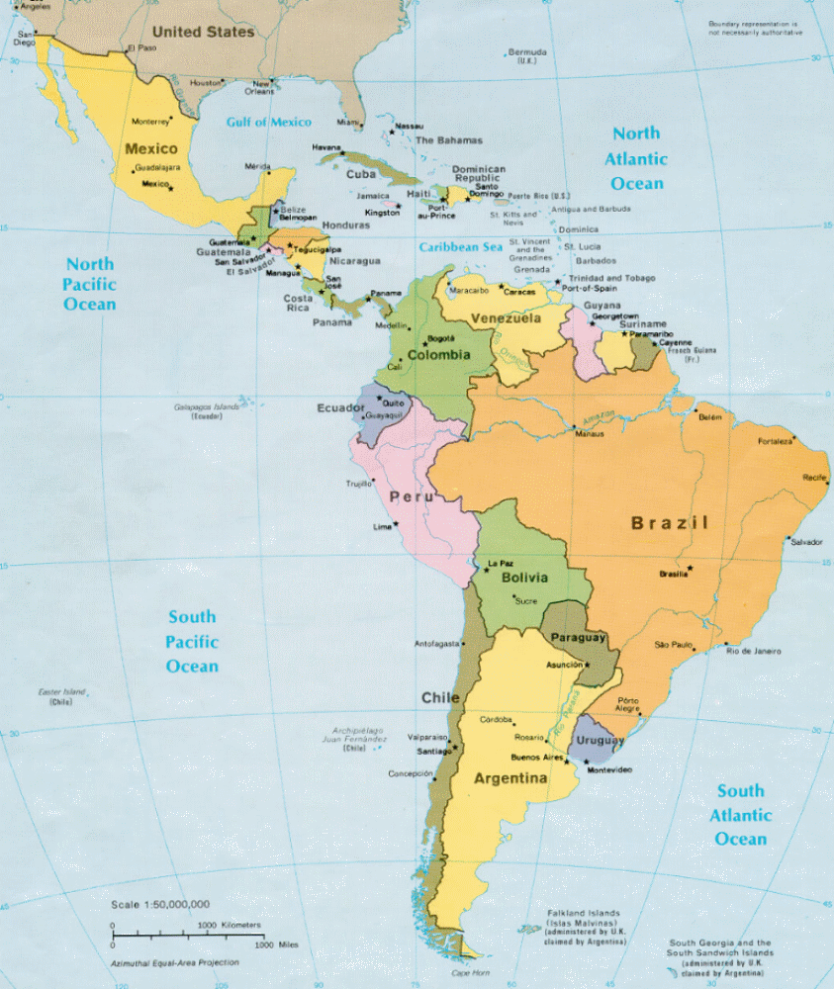

16

